
SWAMI RAMANAND TEERTH MARATHWADA
UNIVERSITY, NANDED

Project work on
ROLE OF PHYTOMEDICINES IN DIABETES MELLITUS

B. Pharm-7th Semester

By
GITTE SANGMESHWAR NAGNATH
B. Pharm

Guide
MR. PAWAR. A. A SIR
Department of Pharmaceutical chemistry


Shri Sambhaji Foundation Nanded
Shri Sambhaji College of Pharmacy
Degaon road, Opp. Nandla Digras, Khadkut,Nanded

2025-2026

Shri Sambhaji Foundation Nanded
SHRI SAMBHAJI COLLEGE OF PHARMACY
Degaon Road, opp. Nandla Digras, Khadkut, Nanded-431605

ENDORSEMENT BY THE PRINCIPAL/
HEAD OF THE INSTITUTION

This is to certify that the Project work embodied in this Project entitled,ROLE OF PHYTOMEDICINES IN DIABETES MELLITUS submitted to Swami Ramanand Teerth Marathwada University, Nanded was carried out by GITTE SANGMESHWAR NAGNATH at Shri Sambhaji College of Pharmacy, Khadkut under my supervision for the partial fulfillment of the requirement for the award of VIIth sem of Bachelor of Pharmacy in the subject Practice School.

Date:

Place: Nanded

Principal
Shri Sambhaji College of Pharmacy, Khadkut.

Shri Sambhaji Foundation Nanded
SHRI SAMBHAJI COLLEGE OF PHARMACY
Degaon Road, opp. Nandla Digras, Khadkut, Nanded-431605


CERTIFICATE BY THE GUIDE

This is to certify that the Project work embodied in this Project entitled, ROLE OF PHYTOMEDICINES IN DIABETES MELLITUS submitted to Swami Ramanand Teerth Marathwada University, Nanded was carried out by GITTE SANGMESHWAR NAGNATH at Shri Sambhaji College of Pharmacy, Khadkut under my guidance in the partial fulfillment of the requirement for the award of VIIth sem of Bachelor of Pharmacy in the subject Practice School. The extent and source of information / materials as has been obtained by candidate from other sources has been duly acknowledged by his in the Project.

Date:

Place: Nanded.

Guide
Mr. Pawar. A. A


Shri Sambhaji Foundation Nanded
SHRI SAMBHAJI COLLEGE OF PHARMACY
Degaon Road, opp. Nandla Digras, Khadkut, Nanded-431605

DECLARATION BY THE CANDIDATE

The Project work embodied in this project entitled, ROLE OF PHYTOMEDICINES IN DIABETES MELLITUS was carried out by me in the VIIth sem of Shri Sambhaji College of Pharmacy, Khadkut under the guidance of Mr. Pawar. A. A Sir for the partial fulfillment of the requirement for the award of VIIthSem of B.Pharm Final yr in the subject Practice School.

Date:

Place: Nanded.

Mr. Gitte Sangmeshwar Nagnath

THE PRACTICE SCHOOL PROJECT WORK

Title of the School Work Project:-ROLE OF PHYTOMEDICINES IN
DIABETES MELLITUS.
Work Carried at :- Shri Sambhaji College of Pharmacy
Name of Student :- Gitte Sangmeshwar Nagnath
Exam Seat No :-
Year :- Final Year B Pharm.

The Practice School Work Submitted for the Partial Fulfillment of 7th Sem B.Pharm Final Year under the supervision.

Mr. Atak S.G.
Asst. Professor Dept. Of Pharmacology
Shri Sambhaji College of Pharmacy

INDEX
Sr. No | Contents | Page no.
1. | Abstract | 7
2. | Introduction | 8-13
3. | Side effects of current antidiabetic drugs | 14
4. | Herbal formulation | 15
5. | Herbal plants with antidiabetic activity | 16-19
6. | Currently used polyherbal formulations | 20
7. | Aims and Objectives | 21
8. | Conclusion | 22
9. | Reference | 23-24

ABSTRACT
Diabetes mellitus is most common metabolism disorder resulting from either insulin insufficiency or insulin disfunction. Diabetes mellitus affect most of the people of developed and developing countries. 2.8% of the population suffers from this throughout the world. The IDF Atlas (2021) reports that 10.5% of the adult population (20-79years) has diabetes, with almost half unaware that they are living with the condition. By 2045, IDF Atlas projections shows that there will be increase of 46% in above percentage, that means 1 in 8 adults will be living with diabetes. In ancient times, chemicals and extracts derieved from different natural resources particularly plants have been effective tool fir treating diabetes. There are many chemicals and biochemical agents that help in controlling diabetes but There is no permeants remedy available which help in complete recovery from this disorder. Oral hypoglycemic agents like sulfonylureas and biguanides are mostly used in diabetes mellitus. The treatment with synthetic drugs is costly and changes of side effect are high, therefore there is growing interest in herbal remedies. Medicinal plants are therefore used majorly for the treatment of diabetes mellitus. Majority of plants belongs to Apocynaceae, Asteraceae, Euphorbeaceae, Lamiaceae. Several formulations prepared from medicinal plants include herbal teas, extracts, decoction, infusions, tinctures. Most of the preperations were made from leaves of medicinal plants (63%) and mainly used as decoction. Antidiabetic activity of medicinal plants is due to the presence of phenolic compounds,flavonoids,terpenoids,coumarins and other constituents which show reduction in blood glucose level. Several medicinal plants and their preperations have been demonstrated to act at main points of glucose metabolism.

Keywords: Diabetes mellitus, Oral hypoglycemic agents, Medicinal plants, Glucose metabolism, Herbal remedies.

INTRODUCTION
[1] Diabetes mellitus:
Diabetes mellitus is non infection endocrine disorder. It is characterized by the disturbance in metabolism of carbohydrate and is linked with developing of various serious diseases like nephropathy, neuropathy, retinopathy and coronary heart disease, periferal vascular disease. Glucose blood level are maintained by insulin which is hormone released from pancreas. In diabetic patients, the production of insulin is absent or less which causes hyperglycemia. Around 1500 B.C physicians in India noticed the sweetness in urine of diabetic patients and called it as “Madhumeha”. Diabetes mellitus is associated with the formation of harmful compounds known as keton bodies.
- Classification:
Diabetes Mellitus is three types:
- Type1 diabetes mellitus: Also called as “Insulin Dependent Diabetes Mellitus “. It occurs due to loss of function of B-cells of Langerhans present in pancreas. Autoimmune destruction of B-cell by T-cells is responsible for Type-1 Diabetes Mellitus.
- Type2 diabetes mellitus: Also called as “Non Insulin Dependent Diabetes Mellitus”. Body is capable of producing insulin but become resistant that the insulin is ineffective. It occurs mostly in obese persons. Associated with high blood pressure and high cholesterol level.
- Gestational diabetes mellitus: It is provisional disorder that happens in pregnancy. Gestational diabetes mellitus occurs with hyperglycaemia in pregnant women’s. In this there is a greater risk of morbidity and mortality to foetus, mother and subsequent neonate. Gestational diabetes diagnosed at 24 to 28 weeks of gestation in women.
- Causes:
Autoimmune disorder, Drugs and Chemical toxins, Endocrine disorders, Unfavorable environmental factors, Age, Obesity, Stress, Unhealthy food, High blood pressure, Pancreatic diseases, Hereditary disposition.
- Symptoms:
Polyuria, Polydipsia, Fatigue, Nausea, Polyphagia, Vomiting, Impotence in men, Slow healing wound, Blurred vision, Irritability, Blurred vision, Numbness.
- Complications:
Cardiovascular disease, Depression, Nerve damage(neuropathy), Kidney damage(nephropathy), Eye damage(retinopathy), Foot damage, Skin conditions, Hearing impairment, Alzheimer’s disease.

According to International Diabetes Federation Survey(IDF) in 2016, diabetes affects 415 million people in world.it may increase to 642 million by the year 2040.According to Aroma World Reports 61.3 million people have diabetes in INDIA.
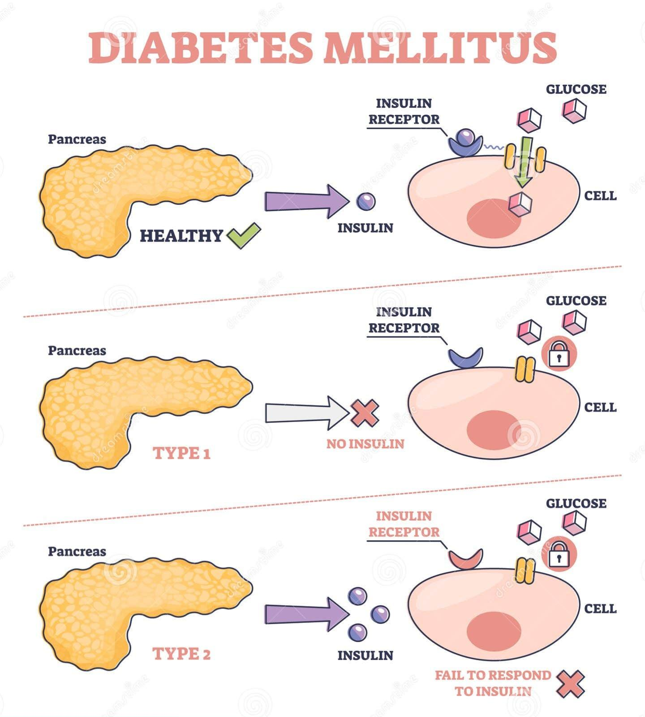
Fig 1: Diabetes Mellitus and Types of Diabetes Mellitus

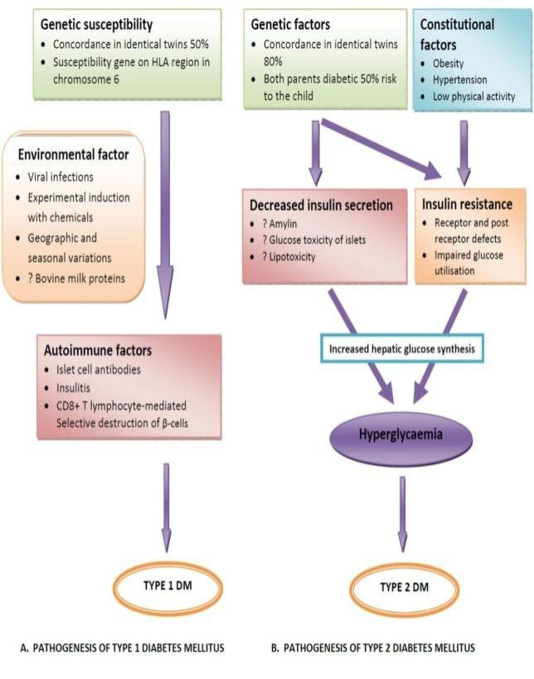
- Pathophysiology of diabetes mellitus:
Fig2: Pathophysiology of diabetes mellitus

- Diagnosis:
- Glycated haemoglobin (A1C) test: This blood test doesn’t require fasting. It indicates average blood sugar level for past 2-3 months. It measures percentage of blood sugar attached to haemoglobin, oxygen-carrying protein in red blood cells. The higher your blood sugar level, more haemoglobin you’ll have with sugar attached.
- A1C level of 6.5% and above indicates diabetic condition.
- A1C level between 5.7% to 6.4% indicates prediabetic condition.
- A1C level below 5.7% indicates normal/non-diabetic condition.
- Random blood sugar test: Blood sample will be taken at a random time. Regardless of when you last ate, a random blood sugar level of 200 milligrams per deciliter (mg/dL) – 11.1 mmol/L or higher indicates diabetes.
- Fasting blood sugar test: Blood sample will be taken after an overnight fast.
Fasting blood sugar level:
- Less than 100mg/dL (5.6mmol/L) – Normal.
- From 100 to 125mg/dL (5.6 to 6.9mmol/L) – Prediabetes.
- 126mg/dL (7mmol/L) and above – Diabetes.
- Oral glucose tolerance test: Fasting blood sugar level is measured firstly and then after drinking sugary liquid containing (usually 75gm) sugar, blood sugar levels are tested periodically for the next two hours.
- Blood sugar level less than 140mg/dL (7.8mmol/L) is normal.
- Reading of more than 200mg/dL (11.1mmol/L) after two hours indicates diabetes.
- Between 140-199mg/dL (7.8-11.0mmol/L) indicates prediabetes.

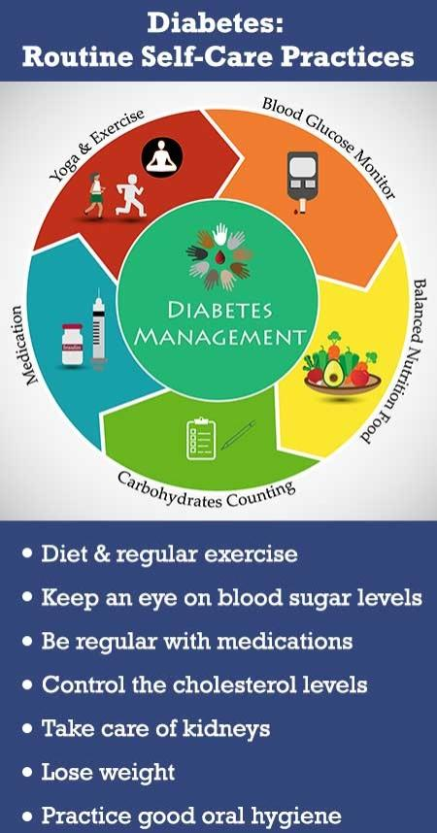
- Management of diabetes mellitus:
Fig3: Management of diabetes mellitus

- Treatment of diabetes mellitus:
Diabetes mellitus disease can be prevented by regulating blood sugar level with various types of medicines, acquiring to different exercise or yoga therapy or diet plan.Treatment of diabetes mellitus involves insulin treatment and oral hypoglycemic drugs like sulfonylureas, thiazolidinediones, peptide analogues. The regular follow-up of diabetic patients with the health care provider is very important in preventing any long term complications.
Treatment of diabetes mellitus involves two types therapy:
[1] Non-pharmacological treatment: This involves treatment without using any drug or medicine.
[2] Pharmacological treatment: This involves treatment by using different drugs or medicine.
Diabetes mellitus is prevented by maintaining blood sugar level, body weight, quality of life, lifestyle, improving diet.

[2] Phytomedicines:
Phytomedicines are defined as the medicines or extracts that are obtained from plant source,herbs,etc. According to WHO, 21,000 plants have been listed, which are utilized for therapeutic rationale around the world. According to world ethnobotanical 800 medicinal plants are used for the prevention of diabetes mellitus. Around 450 medicinal plants possess antidiabetic properties from which 109 medicinal plants have complete mode of action. Treatment of diabetes mellitus with synthetic drugs is costly and chances of side effects are high. Therefore there is increased interest in medicines obtained from plants. These are called as “phytomedicines”. The use of these medicines is relatively cheap, no side effects, eco-friendly. Traditional herbal medicines has been used since accident time in many parts of world. The many side effects of insulin therapy and oral hypoglycemic agents necessitate the use of more effective and safer antidiabetic drugs. Plant based drugs are considered to be less toxic. Hence, they player important role as alternative medicine. Phytomedicines are mainly whole, fragmented or cut parts of plants, algae, fungi, lichen in an unprocessed state, usually in dried form, but sometimes fresh. Synthetic drugs used for the treatment have some side effects like sickness, vomiting, dysentery, alcohol flush, migraine, swelling, malignant anemia, faintness. Herbal medicines are easily available without prescription and are also used when the synthetic drugs doesn’t shows it’s effects.

SIDE EFFECTS OF CURRENT ANTIDIABETIC DRUG’S
Table1: Side effects of currently available antidiabetic drugs
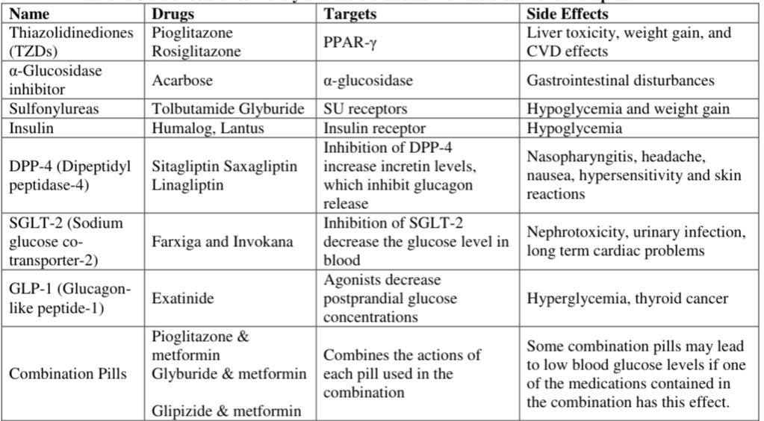

HERBAL FORMULATIONS
Herbal formulations are prepared from the natural herbs, fruits, vegetables extracts which are beneficial in treatment of various diseases without adverse effects. Herbal formulations are eco-friendly and cheap as compared to chemical drugs. Currently the medicinal plants and herbs are used in extracts form for their antidiabetic activity. Various clinical studies confirmed that the medicinal plant extracts shows antidiabetic activity and restoring action of B-cells in pancreas.
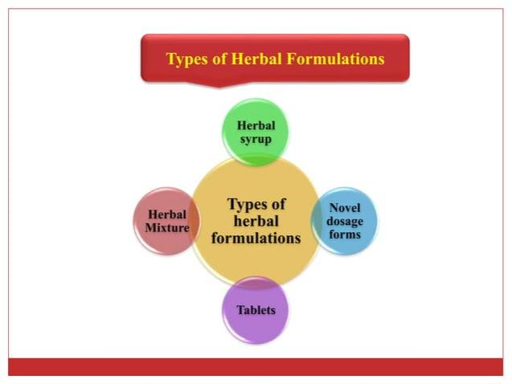
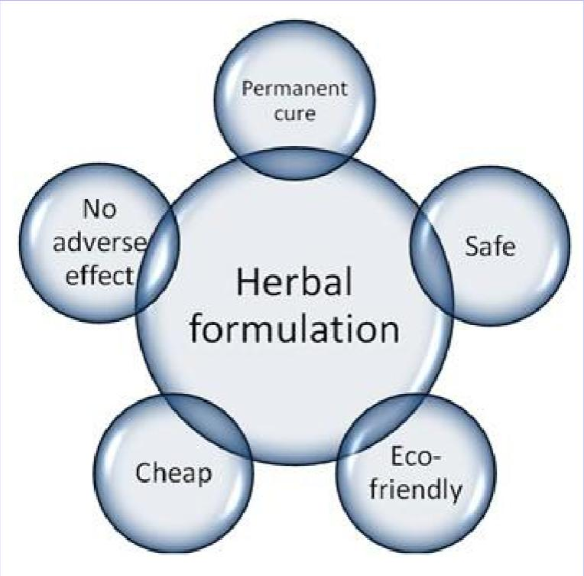

Fig4: Advantages of herbal formulations Fig5: Types of herbal formulations

- Herbal formulations are available in various forms:
- Herbal syrups.
- Tablets.
- Novel dosage forms.
- Herbal mixtures.

HERBAL PLANTS WITH ANTIDIABETIC ACTIVITY
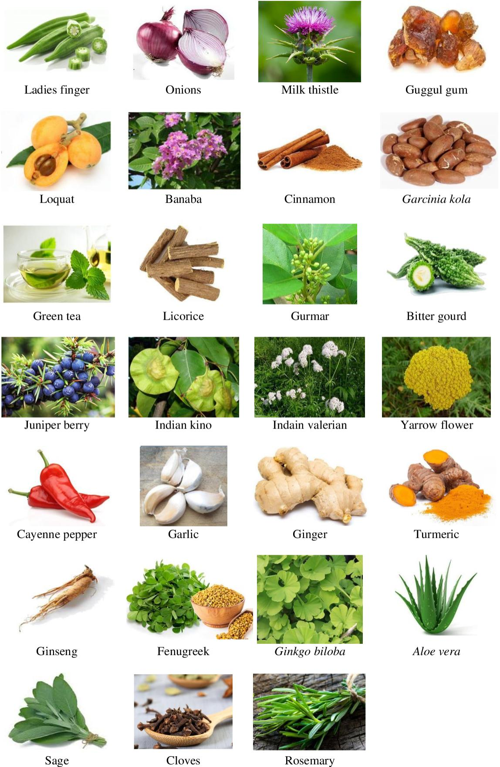

- Some examples of herbal plants having antidiabetic activity:
- Garlic:
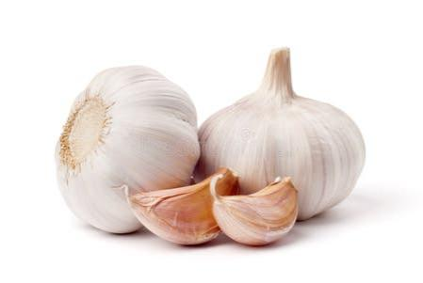
- Scientific name: Allium sativum
- Biological source: It consists of bulb of plant allium sativum belonging to family Liliaceae.
- Chemical constituents: Garlic bulb contains 29% carbohydrates, 56% proteins (albumin), 0.1% fat, mucilage, 0.06-0.1% volatile oils. Volatile oils is the main active constituent. It contains allyl propyl disulphide, diallyl disulphide, alliin, allicin. Garlic oil is yellow in colour.
- Uses: (1) Garlic cloves lowers blood sugar. (2) presence of disulphides like allyl propyl and diallyl sulphide in garlic play role in decrease of blood glucose levels. (3) It is mostly useful for patients with type 2 diabetes mellitus.

- Neem:
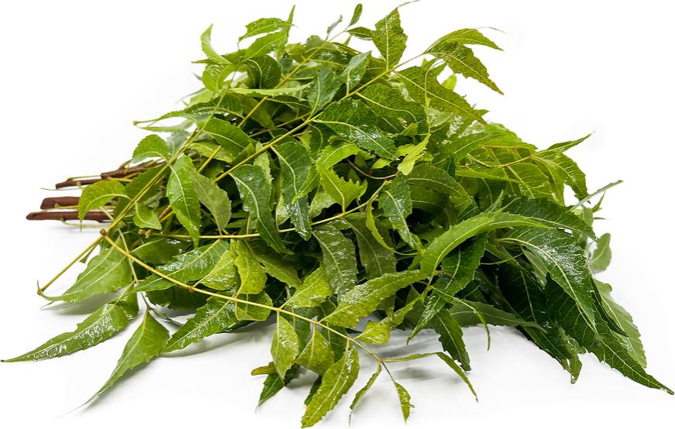
- Scientific name: Azadirachta indica
- Biological source: It is obtained from the leaves of azadirachta indica belonging to the family Meliaceae.
- Chemical constituents: It contains glycerides of saturated and unsaturated fatty acids. The main fatty acids are oleic acid(50%) and stearic acid(20%). Oils contains 2% of bitters, i.e sulpher containing compounds, nimbidin, nimbin, nimbinin, nimbidol. Unsaponifiable part contains nimbosterol(0.03%). The main limonoids present is azadirachtin. It also contains nimbin, salannol, azadiradione, vepinin, vilasinin, fraxinellone.
- Uses: (1) It is used in the treatment of diabetes mellitus.

- Gulvel:
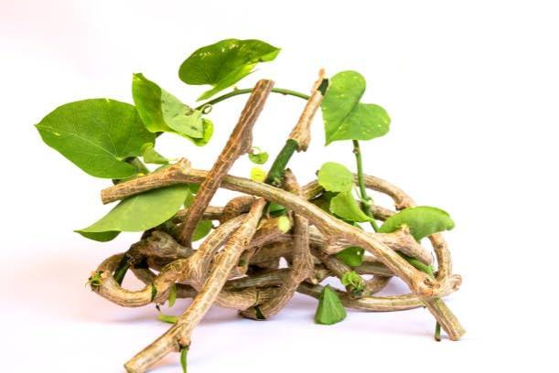
- Scientific name: Tinospora cordifolia.
- Biological source: It consists of stems and roots of tinospora cordifolia belonging to family Menispermiaceae.
- Chemical constituents: The active adaptogenic constituents are diterpene compounds include tinosporone, tinosporic acid, the yellow alkaloid, berberine, giloin, crude giloininand, polysaccharides including arabinogalactan polysaccharide, picrotine, bergenine. Active principle of tinospora cordifolia, was found to possess anticomplementary and immunomodulatory activities.
- Uses: (1) It is used as antidiabetic agent.

- Cinnamon:
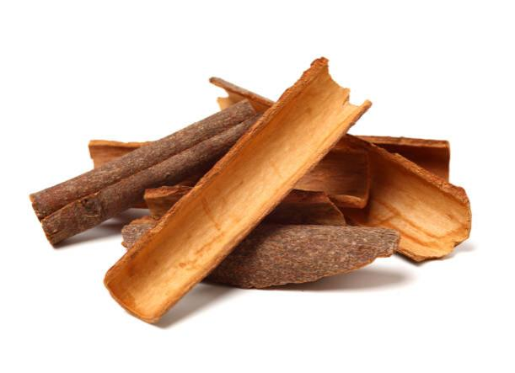
- Scientific name: Cinnamonum zeylanicum.
- Biological source: It consists of dried inner bark of shoots of coppiced tree of cinnamonum zeylanicum, belonging to family Lauraceae.
- Chemical constituents: Cinnamon bark contains tannins, volatile oils, mucilage, starch, calcium oxalate and mannitol. Cinnamon oil contains cinnamaldehyde, other terpenes like phellandrene, pinene, cymene, caryophyllene.
- Uses: (1) It is used in treatment of type-2 diabetes mellitus and insulin resistance. (2) It is used in diabetic patients who have co-existing hypertension.

- Fenugreek:
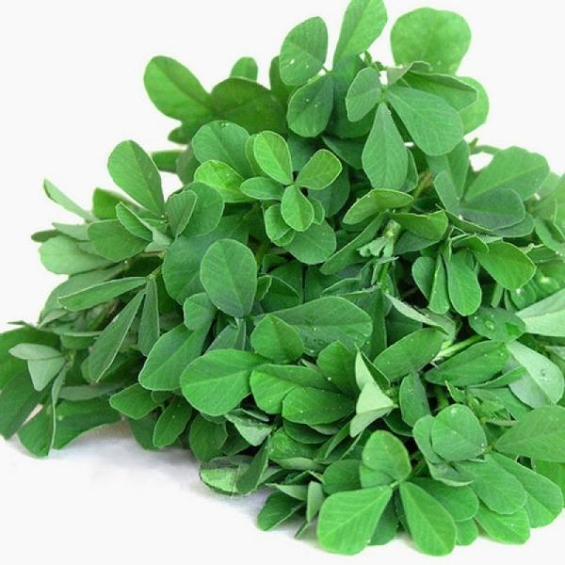
- Scientific name: Trigonella foenum-graccum.
- Biological source: It is obtained from the leaves and seeds of trigonella foenum-graccum, belonging to family Fabaceae.
- Chemical constituents: The nicotinic acid, alkaloid, trogonelline and coumarin contain by defatted section of the seed of fenugreek prove to be the responsible active ingredient for it’s antidiabetic property.
- Uses: (1) It is used for an antidiabetic activity. (2) It helps in regulating cholesterol level. (3) fenugreek also helps in weight loss by increasing burning of abdominal fat and fatty tissues.

- Turmeric:
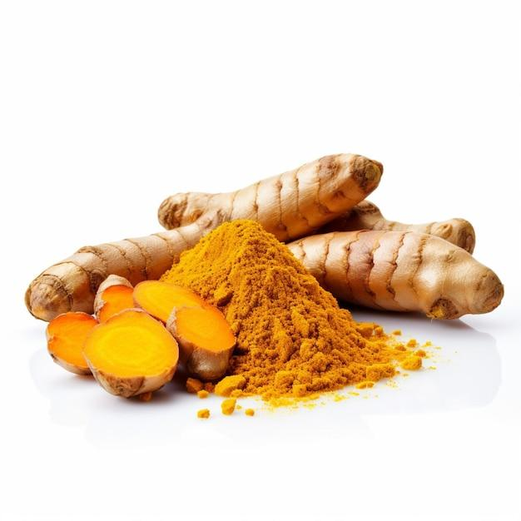
- Scientific name: Curcuma longa.
- Biological source: It consists of dried fresh rhizomes of plant curcuma longa belonging to family zingiberaceae.
- Chemical constituents: It contains 5% volatile oil, resins, zingiberacious starch grains and yellow colour curcuminoids. Curcumin is the main component of curcuminoids. Volatile oils are composed of mono and sesquiterpenes. These consists of alpha and beta pinene, alpha phellandrene, camphor, camphene, zingiberene, alpha and beta curcumenes.
- Uses: (1) It is used for an antidiabetic activity. (2) curcumin is used as interference in pre-diabetes therapy to prevent progression of type-2 diabetes mellitus.

- Gurmar:
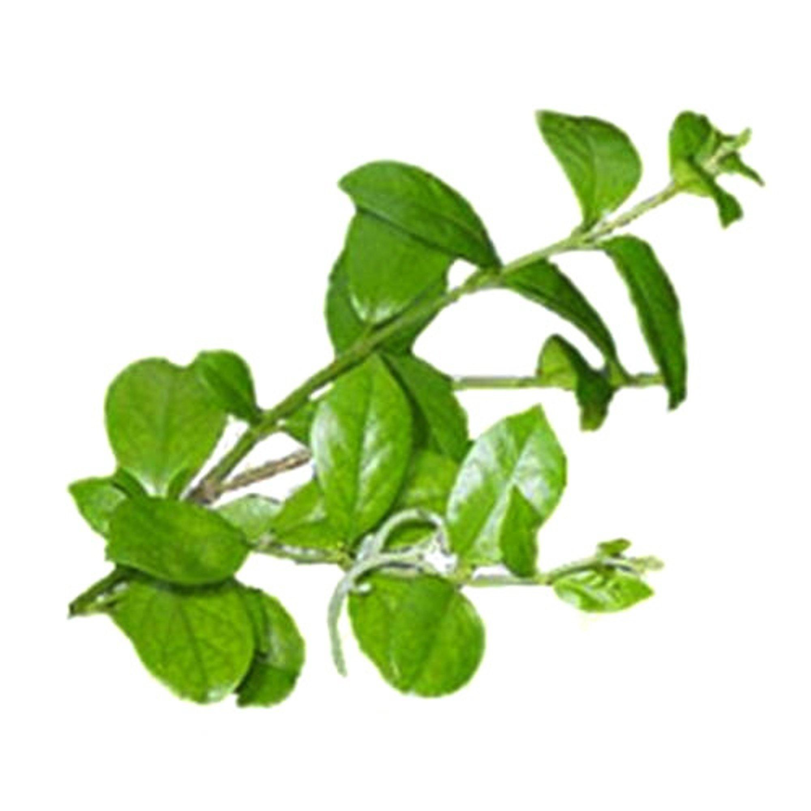
- Scientific name: Gymnema sylvestre.
- Biological source: It is obtained from leaves and roots of plant Gymnema sylvestre belonging to family Asclepiadaceae.
- Chemical constituents: Principle active ingredient is gymnemic acid. It also contains calcium oxalate, anthraquinone compounds, tartaric acid, cellulose but no tannin is present.
- Uses: (1) It is one of the main herb used for healing diabetes mellitus. (2) It removes sugar from pancreas, restores pancreatic function. (3) Stimulate circulatory system, increases urine secretion.

- Indian kino tree:
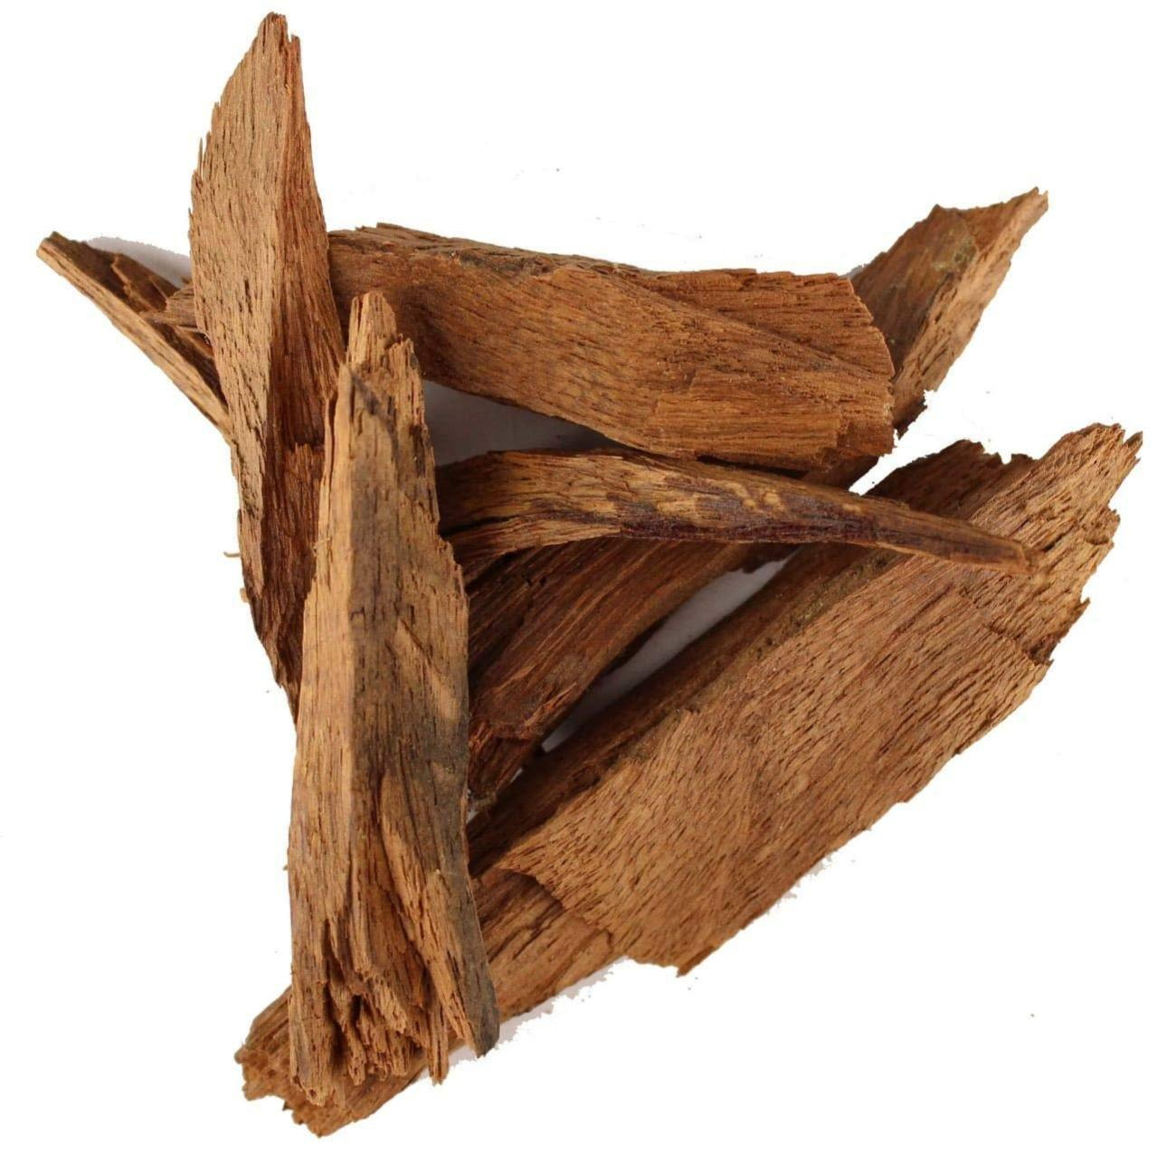
- Scientific name: Pterocarpus marsupium.
- Biological source: It is obtained from dried juice of plant pterocarpus marsupium and obtained by making vertical incisions on stem bark and belongs to family Leguminoceae.
- Chemical constituents: It contains 70-80% kinotannic acid, kino-red, k-pyro catechin (catechol), resin, gallic acid. Kinotannic acid is glucosidal tannin, kino-red is anhydride of kinoin. Kinoin is an insoluble phlobaphene and is made by action of oxydase enzyme. It is darker in colour than kinotannic acid.
- Uses: (1) Heartwood of the plant is used to treat diabetes mellitus. (2) Gum resin is the only herbal product ever found to regenerate B-cells that produce insulin in the pancreas.

CURRENTLY USED POLYHERBAL FORMULATIONS
Name | Company | Ingredients
Diabecon | Himalaya | Gymnema sylvestre, pterocarpus marsupium, Glycerhiza glabra, Caseariae sculenta.
Diasulin | Tobbes Busindo | Cassia auriculanta, Emblica officinalis, Coccinia indica, Gymnema sylvestre, Curcuma longa.
Bitter guard powder | Garry and sun natural remedies | Momordica charantia.
Dia-care | Admark Herbals limited | Sunjeevan mool, Kadu, Jambulbeej, Neemchal.
Gurmar powder | Garry and sun natural remedies | Gymnema sylvestre.
Epinsulin | Swastik formulations | Pterocarpus marsupium.
Diabeta | Ayurvedic cure Ayurvedic herbal health products | Gymnema sylvestre, Vinca roses, Curcuma longa, Azadirachta indica, pterocarpus marsupium.
Syndrex | Plethico laboratories | Germinated fenugreek seed extract.

AIM AND OBJECTIVES
AIM:
The aim of this study is –
- To determine the prevalence of the use of herbs in diabetics and which herbal are used.
- To investigate the effect of some demographic characteristics on the use of such drugs.
OBJECTIVES:
- Treatment of disease.
- Maintain blood pressure and cholesterol level.
- Re-create normal or nearly normal blood glucose level.
- Reducing the risk of complications like heart diseases, kidney diseases, eye diseases.
- Improve quality of life.

CONCLUSION
Diabetes mellitus is most common endocrine disorder, affecting more than 300 million people’s worldwide. For this, conventional therapies are often limited in efficacy, costly, and have risk of adverse effects. Therefore, medicine or compounds obtained from plants which do not require laboratory synthesis seems highly effective.
Isolation and identification of active constituents from these plants, preperation of standardized dose and dosage form play significant role in improving the hypoglycemic action.
The aboe mentioned plants have been considered for their possible hypoglycemic actions and the researchers have carried out some preliminary investigation. It is important to know the active constituents and their molecular interaction which will help to analyze the therapeutic efficacy of the product and also to standardize product.

REFERENCE
- Kumar A, Goel MK. Jain RB, Khanna P,Chaudhary V. India towards diabetes control: Key issues. Australasian Medical Journal;2013.
- Rahimi M. A Review: Anti Diabetic medicinal plants used for diabetes mellitus. Bulletin of environmental, pharma- cology and life. Sciences;2015.
- Arumugam G, Manjula P, Paari N. A review :Antidia- betic medicinal plants used for diabetes mellitus. Journal of acute diseases; 2013.
- Bordoloi R, Dutta KN. A Review on Herbs Used in the Treatment of Diabetes mellitus.Journal of Pharmaceutical, Chemical and Biological. Sciences;2014.
- Mandal S, Vishvakarma P. Nanoemulgel: A Smarter Topical Lipidic Emulsion-based Nanocarrier. Indian J of Pharmaceutical Education and Research. 2023;57(3s):s481-S498.
- Lipinski B. Pathophysiology of oxidative stress in diabetes mellitus. Journal of Diabetes And its Complications. 2001 Jul 1;15(4):203-10.
- Davis R.H., Maro N.P. Aloevera and gibberellins, Anti-inflammatory activity in Diabetes. J. Am. Pediat. Med. Assoc. 1989; 79:24–26.
- Bedu-Ferrari C, Biscarrat P, Langella P, Cherbuy C. Prebiotics and the human gut Microbiota: From breakdown mechanisms to the impact on metabolic health. Nutrients. 2022 May 17;14(10):2096.
- Modak M, Dixit P, Londhe J, Ghaskadbi S, Devasagayam TP. Indian herbs and herbal Drugs used for the treatment of diabetes. Journal of clinical biochemistry and nutrition.
- Hannan J.M., Ali L., Rokeya B., Khaleque J., Akhter M., Flatt P.R., Abdel- Wahab Y.H.-Soluble dietary fibre fraction Of Trigonella foenum-graecum (fenugreek) seed improves Glucose homeostasis in animal models of type 1 and type 2 Diabetes by delaying carbohydrate digestion and absorption, And enhancing insulin action.
- NAJMA ZAHEER BAQUER, PARDEEP KUMAR, ASIA TAHA, RK KALE, SM COWSIK and P MCLEANMetabolic and molecular action of Trigonella foenumGraecum (fenugreek) and trace metals in experimental Diabetic tissues.
- Bawadi Hiba A., Maghaydah Sofyan N.; Tayyem Rabab F., Tayyem Reema F.- The Postprandial Hypoglycemic Activity Of Fenugreek Seed and Seeds’ Extract in Type 2 Diabetics: A Pilot Study.
- Ojewole JA. Hypoglycemic effect of Sclerocarya birrea [(A. Rich.)Hochst.Anacardiaceae] stem-bark aqueous extract in Rats. Phytomedicine 2003, 10, 675-681.
- Beh JE, Latip J, Abdullah MP, Ismail A, Hamid M. Scoparia Dulcis (SDF7) endowed with glucose uptake properties on L6 myotubes comparedinsulin. J Ethnopharmacol 2010, 129, 23-33.
- Pari L, Latha M. Antihyperlipidemic effect of Scoparia Dulcis (sweet broomweed) in streptozotocin diabetic rats. J Med Food 2006, Spring, 9, 102-107.

- Saxena AM, Bajpai MB, Murthy PS, Mukherjee SK. Mechanism of blood sugar lowering by a Swerchirin Containing hexane fraction (SWI) of Swertia chirayita. Ind J Exp Biol 1993, 31, 178-181.
- Gray AM, Flatt PR. Pancreatic and extra-pancreatic effects Of the traditional anti-diabetic plant, Medicago saliva.
- Udayakumar R, Kasthurirengan S, Vasudevan A, Mariashibu TS, Rayan JJ, Choi CW, Ganapathi A, Kim SC. Antioxidant effect of dietary supplement Withania somnifera L. reduce bloodglucose levels in alloxan-induced diabetic rats. Plant Foods Hum Nutr 2010, 65, 91-98.
- Hoda Q, Ahmad S, Akhtar M, Najmi AK, Pillai KK, Ahmad SJ. Antihyperglycaemic and antihyperlipidaemic effect of poly-constituents, in aqueous andchloroform extracts, of Withania coagulans Dunal in experimental type 2 diabetes mellitus in rats. Hum Exp Toxicol 2010, 29, 653-658.
- Hemalatha S, Wahi AK, Singh PN, Chansouria JP. Hypoglycemic activity of Dunal in streptozotocin induced diabetic rats. J Ethnopharmacol 2004, 93, 261-264.
- Anand KK, Singh B, Chand D, Chandan BK, Gupta VN. Effect of Zizyphus saliva leaves on blood glucose levels in normal and alloxandiabeticrats. J Ethnopharmacol 1989, 27, 121-127.

Date:

Place : Nanded

Name of student Name and Signature of Guide Principal
Gitte Sangmeshwar Nagnath Mr. Pawar. A. A.

Practice School Project Work
2025-2026
Final Evaluation Report
Name of Student: Gitte Sangmeshwar Nagnath
Roll No.: 27
Exam Seat No.:
Name of Teacher : Mr. Pawar. A. A
Title of Practice School: Role of phytomedicines in diabetes mellitus.
Evaluation Details:-
Sr. No | Components | Date | Max.marks | Obtained marks
1. | Topic submission |  | 10
2. | Synopsis |  | 15
3. | Ppt of synopsis |  | 20
4. | Project (Hard copy)  (End term) |  | 55
5. | Project Ppt  (End term) |  | 25
6. | Internal assessment  (C.M) | 25
7. | Total marks+C.M | 150
8. | Grade
Recommended final grade:
Grade | Evaluation | Corresponding marks
O | Excellent | 141 and above
A | Very good | 126-140
B | Good | 106-125
C | Fair | 91-105
D | Satisfactory | 75-90
E | Poor | Below 75

Name of guide: Mr. Pawar. A. A
Sign:

